

Darom And Stem Doctoral Fellowships
Application form for an academic scholarship for Ph.D. applicants
Fellowship applied to (mark one)
☐ Darom (outstanding students applying to Ph.D. studies following undergraduate studies – Direct track only)
☒ STEM (new excellent applicants for STEM research)

- Personal Details
Picture: 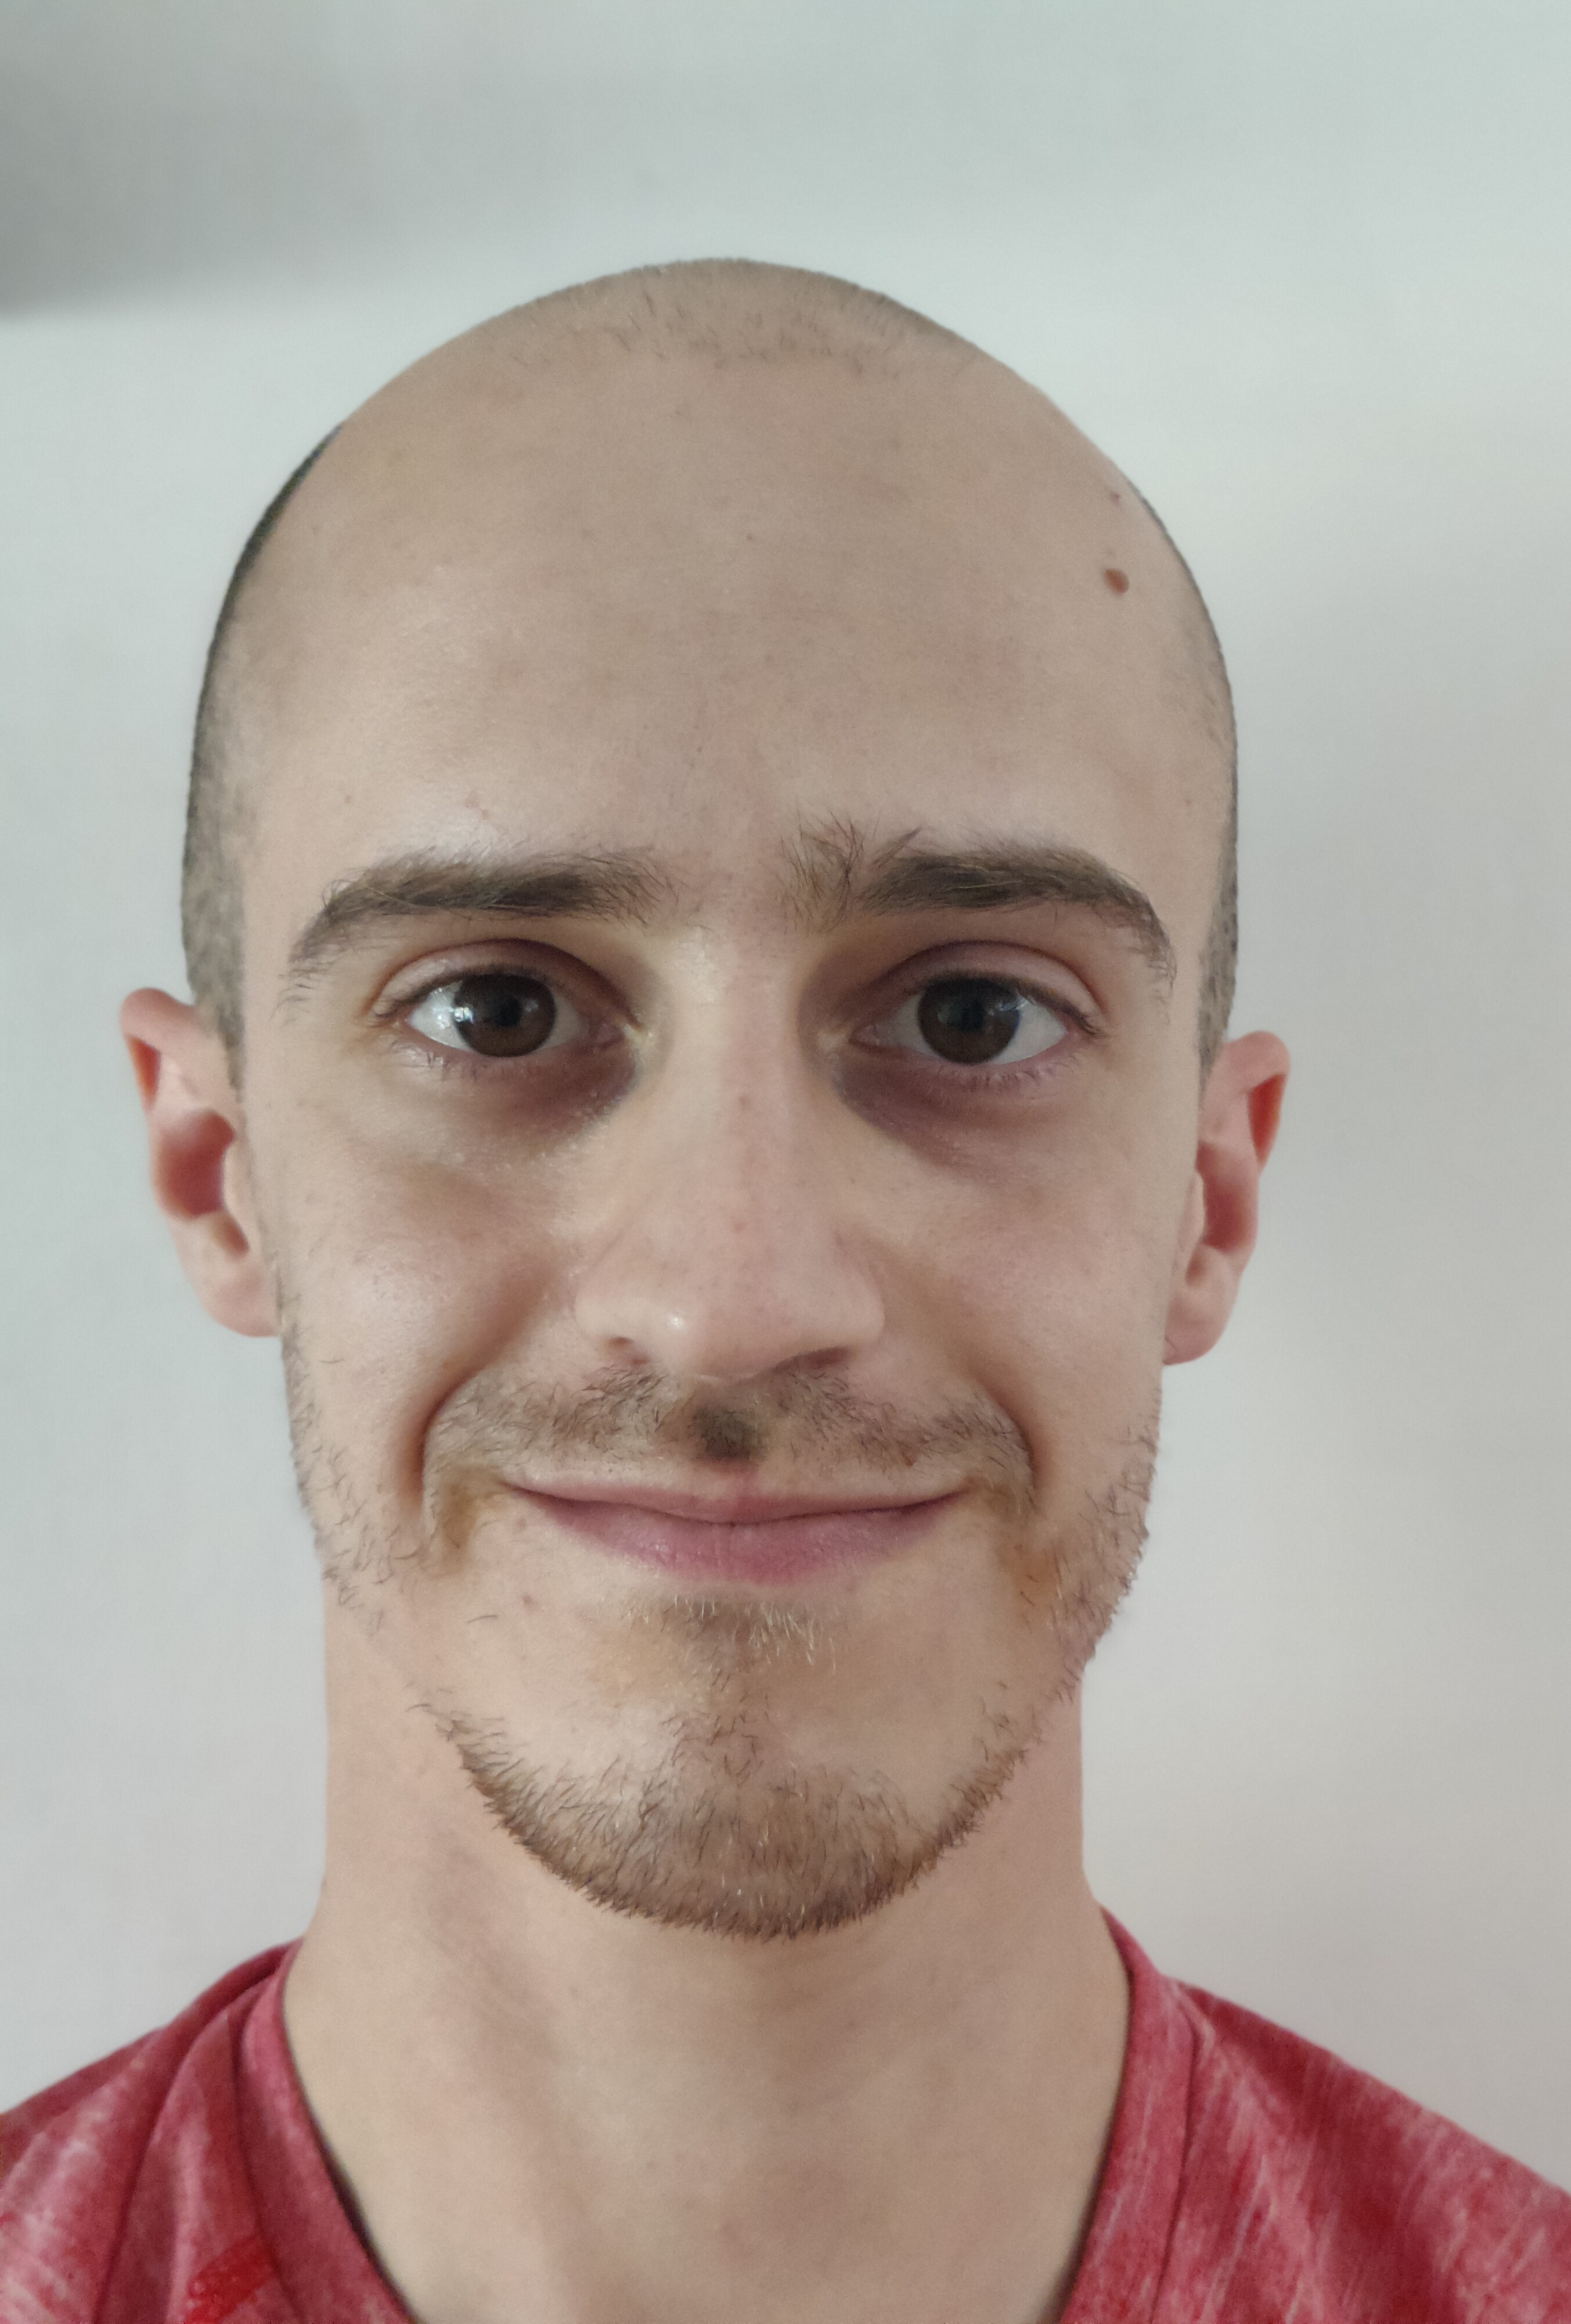
First name: Roy-Israel
Family name: Prishkulnik
Department: Physics
Ph.D. Advisor: Moshe Schechter
Starting date of Ph.D. studies: 10/2026
ID/Passport number: 315784553
Citizenship: Israeli
Date of Birth: ‏20/08/1996
Address: Golomb 45, Beer Sheva
E-mail address: prishkro@post.bgu.ac.il
ORCID 0009-0007-4876-9811
Status of Ph.D. studies at BGU (applied/accepted): Applied
- Academic studies

  - Bachelor (First) Degree
Years. From: 2020 To: 2024
Name of Institution: Ben-Gurion University
Department: Physics
Degree awarded (mark): ☐B.A. ☒B.Sc. ☐Other Click or tap here to enter text.
Final grade: 84.28
Student ranking 25 of 46
Awards and prizes
Award or prize name | Dates | Comments

  - Master/Magister (Second) Degree (If applicable)
Years. From: 2024 To: Click or tap here to enter text.
Name of Institution: Ben-Gurion University
Department: Physics
Degree awarded (mark): ☐M.A. ☐M.Sc. ☐Other Click or tap here to enter text.
Thesis title: TLS Induced Red Shift of Superconducting Cavity Resonance Frequency
Thesis Advisor: Moshe Schechter
Final grade: Click or tap here to enter text.
Thesis grade: Click or tap here to enter text.
Awards and prizes
Award or prize name | Dates | Comments

  - Other Academic information (Fill if applicable)
Click or tap here to enter text.

  - Ph.D Research title
Interactions of TLSs in Amorphous Materials with Superconducting Quantum Devices

  - Rationale for submitting candidacy (Up to half a page, written by the Advisor, stressing the significant intellectual accomplishments of the applicant)
Roy’s research focuses on the effects of noise in superconducting devices. In particular, he studies the loss and frequency shift experienced by superconducting resonators due to their interaction with a bath of tunneling two-level structural defects (TLSs). These defects are ubiquitous in amorphous materials and at interfaces, and constitute one of the dominant sources of noise in superconducting quantum devices at low temperatures.
Roy has successfully calculated the excess loss experienced by a superconducting resonator under a unique bias-sweeping protocol. His work improves upon previous theoretical treatment and provides support for a generalized model of TLSs, in which two distinct classes of defects exist, differing significantly in their coupling to strain. His calculations provide a framework that can be generalized to a broad range of systems, enabling further tests of the validity of this theoretical model.
In a second project, currently in progress, Roy is calculating the frequency shift of superconducting resonators under the same bias-sweeping protocol. Together, these two projects will contribute to a deeper understanding of TLSs and their impact on superconducting quantum devices—a problem of central importance in today's quantum science and quantum technology research.
Roy is a thoughtful, dedicated, and highly motivated student. He approaches research with care and persistence, and I am confident that he will carry out high-quality research throughout his Ph.D.

Advisor name: Moshe Schechter Signature: 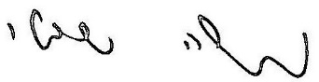

3. A list of publications
Please list all publications in each category, from new to old.
Link to article⁵ | Ranking and Quartile³ | Impact Factor | Year of Publication or status² | Journal / Conference name | Authors List | Manuscript title | Publication type¹
Published or accepted papers (research article, review paper, or ranked conference paper) where you are a primary author (first or co-first)⁴
 |  |  |  |  |  |  |  | 1
 |  |  |  |  |  |  |  | 2
Published or accepted books, book chapters, or workshop papers where you are a primary author (first or co-first)⁴
 |  |  |  |  |  |  |  | 1
 |  |  |  |  |  |  |  | 2
Published or accepted papers, books, book chapters, review papers, or workshop papers where you are a co-author⁴
 |  |  |  |  |  |  |  | 1
 |  |  |  |  |  |  |  | 2
Pending publications, only list manuscripts in which you are the primary author
 |  |  |  |  |  |  |  | 1
 |  |  |  |  |  |  |  | 2
Please add a link to your Author Profile page from https://www.webofscience.com/wos/woscc/basic-search
Author page Link: Click or tap here to enter text.
  - Publication type: Research article, conference paper, book, book chapter, workshop paper, case study, or review. For conference papers, include only CORE-ranked conferences in computer science.
  - For pending publications, note if the manuscript is under review, submitted, or archived (include only online archives, such as arXiv).
  - * Journal Ranking from JCR https://jcr.clarivate.com/jcr/home (please use only ISI ranking from webofscience).
* CORE conference ranking http://portal.core.edu.au/conf-ranks/ * VATAT List
For Journals, note ranking and quartile, for example, 6/73 (Q1). For conferences, note ranking A*. For publications included in the VATAT list, write VATAT.
  - For accepted but not published manuscripts, please attach a status confirmation letter from the journal as an appendix.
In case of an alphabetical author list, list your publications based on your contribution (primary / co-author).
5. Make sure all links are clickable and working.

4. Other details
4.1. Employment statement (you are not eligible to work outside BGU)
☒ I will not be working outside BGU.
☐ Name of the workplace: Click or tap here to enter text. The planned scope of the job (no. of hours weekly or percentage of position): Click or tap here to enter text.
☒ I hereby declare that I will notify the Department Secretariat and The Kreitman School of any changes in the above.

4.2. Additional required details:
Have you applied for any other internal BGU scholarships? ☐Yes ☒No.
If yes, specify Click or tap here to enter text.
Have you applied for any external scholarships? ☐Yes ☒ No.
If yes, specify Click or tap here to enter text.

  - Matching funds by the department or faculty are 2 portions.
- In addition, a four-year tuition scholarship will be awarded on behalf of the Department.
Department Secretariat : Click or tap here to enter text. Signature: 

  - Matching funds by the advisor (Mark one):
☒ I will participate in funding 4 portions of STEM scholarship.
☐ I will participate in funding 3 portions of the Drom scholarship.
☐ I am unable to participate in funding the scholarship (scholarships without advisor matching are allowed in specific disciplines - see regulation for scholarships without matching).
Supervisor name: Moshe Schechter Signature:

